Personnel responsible:
Lead Operator and / or Salt Operator

Safety equipment:
All safety glasses and appropriate safety apparel is to be worn at all times.

Summary:
Checking the bag weights, bagger and super sack weight accuracy

Procedure:
- Salt Operator Logs
  - Every two hours the Salt / Assistant Operator is responsible for checking the weight of a super sack or 50- lbs bag which ever is being run at the time.
    - 50-lb bags are to be weighed using the scale next to the bagger
      - Weight tolerance for the 50-lb bags is ± 0.50-lbs. An empty bag weighs 0.18-lbs so the weight of a filled bag should be between 49.68 & 50.68 lbs
      - If the bag is out of this weight range, another bag is to be weighed immediately. If both are out of range the bagger must be recalibrated.
      - Weights are to be recorded on the operator log and the weight trend chart
    - Super sacks are to be weighed using the floor scales.
      - If super sacks are being ran during the allotted time slot for weight checks the super sack is filled, taken to the floor scale and weighed. The amount is recorded on the log sheet.
      - Weight tolerance for the super sacks is ± 1.0%. An empty sacks and liner weighs 5-lbs and a pallet normally weighs between 30 and 40-lbs so the weight of a filled sack on the pallet should be between 2,015 & 2,065 lbs
      - If the sack is out of this weight range, another sack is to be weighed immediately. If both are out of range the bagger must be recalibrated.
        - Call Maintenance for assistance

- Charting 50-lb weight checks
  - A sheet is provided for the assistant to perform in process weight verification
  - At the beginning of each page is the scale verification
    - Operators are to use a 50-lb weight and record weights in the “check” row
    - If the scale is not at 50.00-lb, the operator should zero scale and check “recal”
  - The assistant Operators are to check the weights of the bags coming from the bagger once every two hours.
    - Date, time, Oper. initials, results are to be place in the row every two hours.
    - If the weight is our of specification ( +/- 0.50 ) the bagger should be recalibrated
    - Plot each weight recording on the chart and connect the dots.
MUST DO
SCALE VERIFICATION
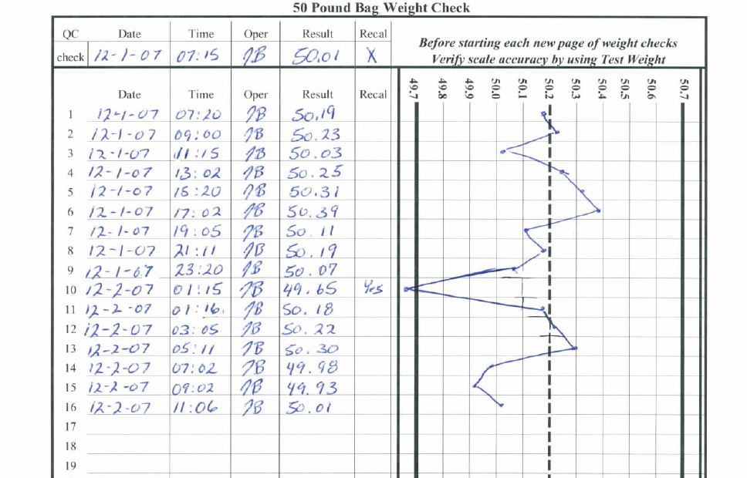
PLOT
WEIGHTS
If out of Spec.
You must recalibrate
TRAINING DOCUMENTATION

 | EMPLOYEE | TITLE | SIGNATURE | DATE
1
2
3
4
5
6
7
8
9
10
11
12
13
14
15
16
17
18
19
20
21
22
23
24
25
26
27
28
29
30

Revision  Number | Revision  Date | Revision  Author | Revision Description
00 | 10/15/07 | JB | New Document
01 | 05/27/09 | JB | Updated to new Company Format

